DEPARTMENT OF ELECTRICAL AND ELECTRONICS ENGINEERING

ST.ANN’S COLLEGE OF ENGINEERING & TECHNOLOGY,CHIRALA

(Approved by AICTE New Delhi, Permanent Affiliated to JNTUK, Kakinada )
(Accredited Twice by NBA New Delhi, NAAC Accredition with ‘A’ Grade, IE (I) Kolkata)

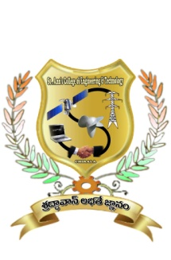

CERTIFICATE

This is to certify that the project report entitled “REDUCTION OF CURRENT RIPPLE BY USING INTERLEAVED BOOST CONVERTER FOR RENEWABLE ENERGY SOURCE ” is the bonafide work done by Mr./Ms……………………………………………………. with Regd no:……………… submitted in the partial fulfillment of the requirements for the award of Bachelor of Technology in ELECTRICAL & ELECTRONICS ENGINEERING of during the academic year (2010-2014). The results embodied in this project report have not been submitted to any other University or Institute for the award of any degree or diploma.

Project Guide Head of the Department
Mr .G.RAMUDU,M.Tech Mr. S.V.D.ANILKUMAR,M.Tech(Ph.D)
Assistant Professor, Department of EEE, Associate Professor, Department of EEE,

Signature of External Examiner

